**Water for elephants**

By: Hosai Sadiq

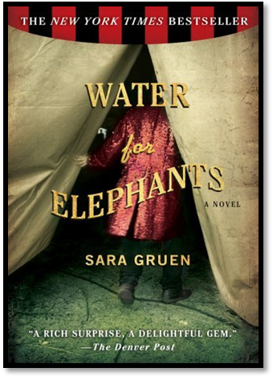

Water for elephants is a book written by Sara Gruen, and is a romantic historical novel.

In this story Water for Elephants, the character Rosy (elephant) has been mistreated by her owner (August). Rosy, in the story is the elephant whose part of the circus, but at the same has been mistreated by the owner abusing her physically and verbally.

Rosy being the main character (protagonist) in this story goes through many difficulties in her life, being the elephant that belongs to the circus, yet not so happy, because she isn’t treated nicely by her owner electrifying the animals (including herself) with metal rods and hitting them.

The circus is a place for people to go and be entertained by the individuals there, but it’s sad to think about those poor animals that have to perform, and at the same time they get mistreated by their owners. Life isn’t always about humans and what they enjoy, because we are not the only species who live on Earth. Before doing anything we must think and remind our self’s about those individual mammals that don’t have what we have and to feel thankful for and to not be cruel to animals.

In my opinion, mistreating animals isn’t right/fair, because all animals have their rights and freedom since they don’t have the chance to talk, we should as humans talk and treat animals as equal as we treat each other, because they belong in the wildlife in the nature were our respect is needed and should be given.

